**实验二 选择结构程序设计**

1.

#include<stdio.h>

main()

{

int n;

printf("input n:");

scanf("%d",&n);

if (n > 9999 || n < 1000)printf("错误！");//判断是否合法

else

{

/*分离出各个数字*/

int a, b, c, d;

a = n / 1000;

b = (n % 1000) / 100;

c = (n % 100) / 10;

d = n % 10;

printf("逆序数为%d%d%d%d\n",d,c,b,a);

/*将各个数字从小到大排列*/

int t;

if(a>b)

{

t = a; a = b; b = t;

}

if (a > c)

{

t = a; a = c; c = t;

}

if (a > d)

{

t = a; a = d; d = t;

}

if (b > c)

{

t = b; b = c; c = t;

}

if (b > d)

{

t = b; b = d; d = t;

}

if (c > d)

{

t = c; c = d; d = t;

}

printf("组成最大数为%d%d%d%d\n",d,c,b,a);

printf("组成最小数为%d%d%d%d\n", a, b, c, d);

}

}

输入合法，结果

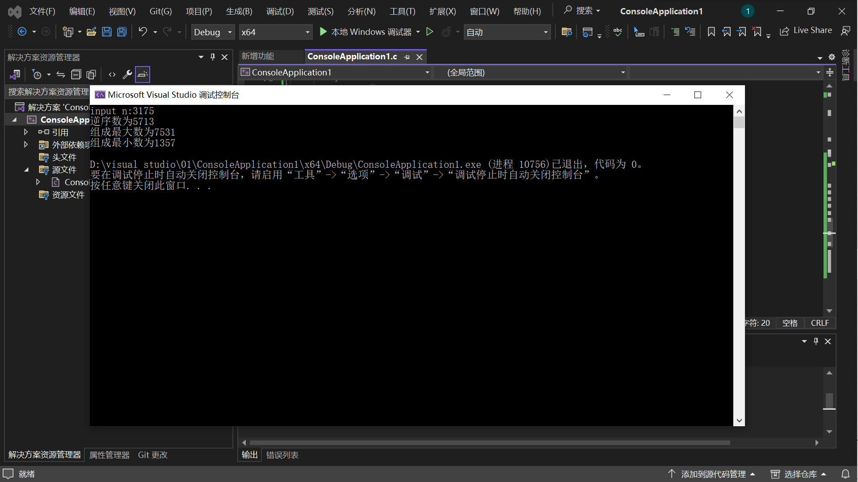

输入非法，结果

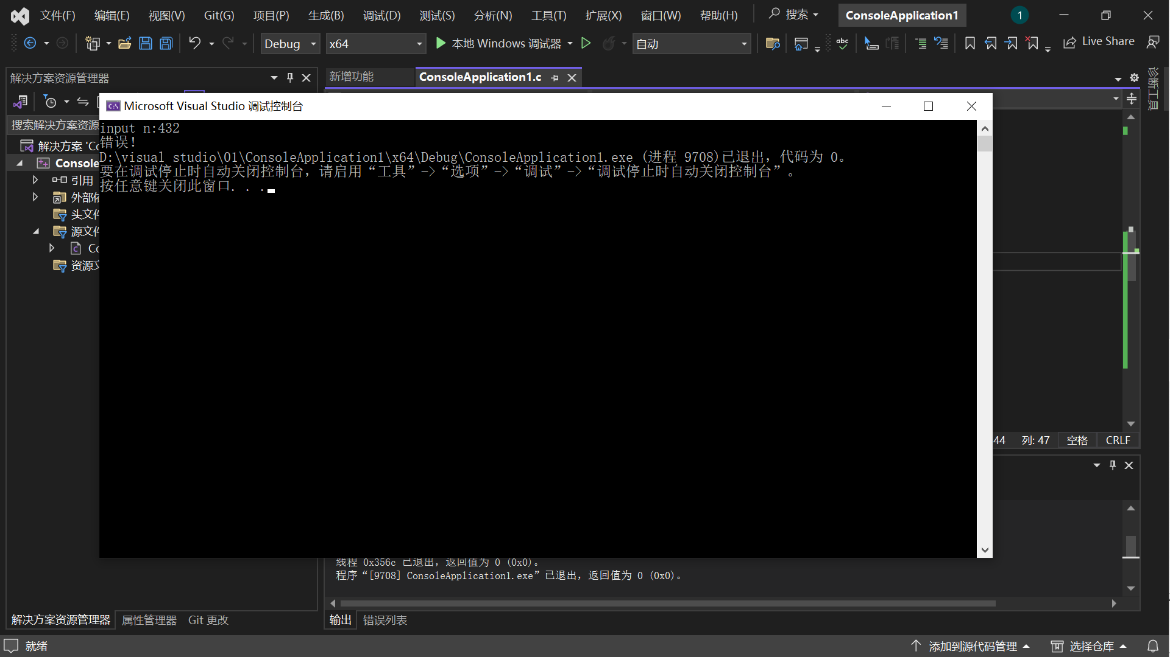

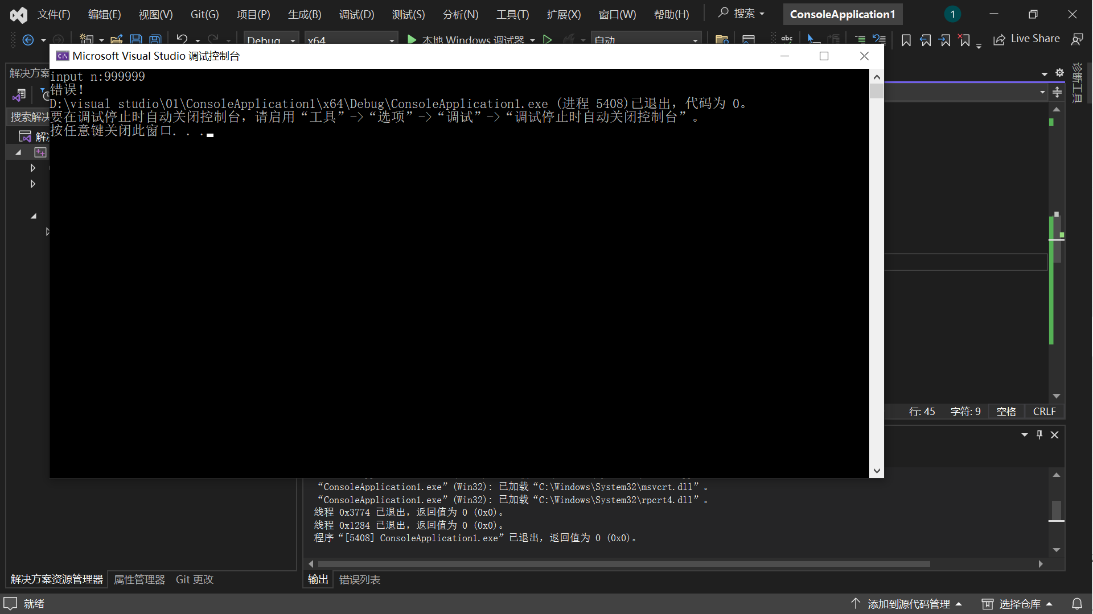

2.

#include<stdio.h>

main()

{

int n;

printf("input number:");

scanf("%d",&n);

if (n > 12 || n < 1)printf("错误！");//判断是否合法

else

{

switch (n)

{

case 1:printf("1 -> January\n"); break;

case 2:printf("2 -> February\n"); break;

case 3:printf("3 -> March\n"); break;

case 4:printf("4 -> April\n"); break;

case 5:printf("5 -> May\n"); break;

case 6:printf("6 -> June\n"); break;

case 7:printf("7 -> July\n"); break;b

case 8:printf("8 -> August\n"); break;

case 9:printf("9 -> September\n"); break;

case 10:printf("10 -> October\n"); break;

case 11:printf("11 -> November\n"); break;

case 12:printf("12 -> December\n");

}

}

}

输入非法，结果

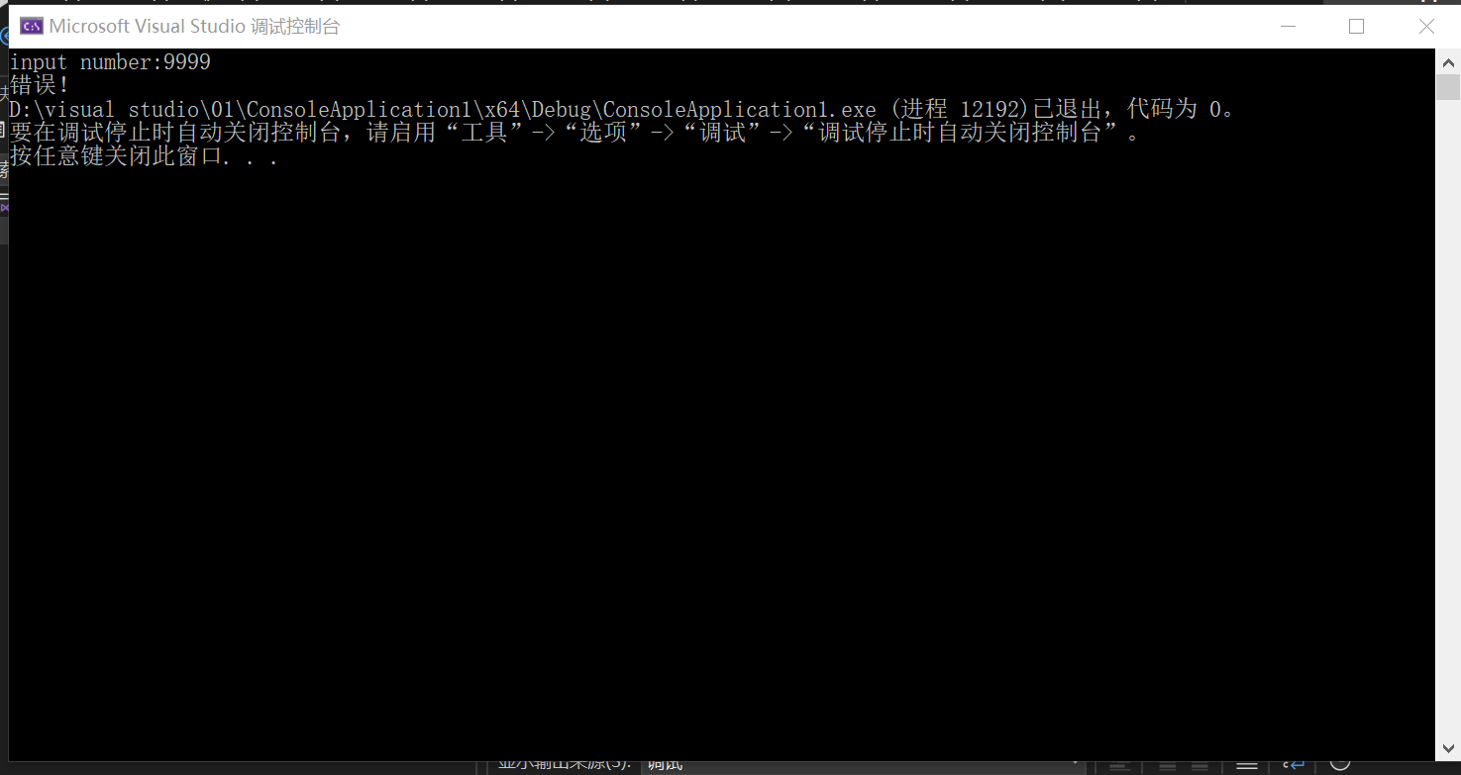

输入合法，结果

